THE TEMPLATE OF THE ENGLISH ARTICLE MANUSCRIPT
{General requirements: The submitted article must be the research work of the author (or team of authors) that has not been previously published or accepted for publication in any other journal. The entire article is in Microsoft Word, using Unicode encoding, Times New Roman font, font size 12 (except for sections with other font sizes indicated); top and bottom margins of 4 cm; left and right margins of 3.3 cm; paragraph spacing of 6pt (except for author names, which should have 12pt spacing); single line spacing; first line indent (First line) of 1.0 cm, with justified alignment on both sides (unless otherwise noted).

Title of the article (font size 13, lowercase, bold, centered)
First Author⁽¹⁾, Second Author⁽¹⁾, n^{th} author^{(2)*} (font size 10, lowercase, centered, 12pt spacing before and after)
⁽¹⁾Name of the affiliation of the first and second authors, address (in italics)
⁽²⁾ Name of the affiliation of the n^{th} author, address
*Corresponding author: - Name:
- Address:
- Tel: Email:
- Highlights (font size 11; italics, bold): This section is required, present the most significant points of the research in 3-5 brief bullet points (each point 1 sentence). (font size 11; normal)
- Abstract (font size 11; italics, bold): Briefly summarize the purpose, research content, and main results, approximately 250 to 300 words in length. References should not be cited in this section. Do not use special characters, symbols, or mathematical formulas in the summary. (font size 11; normal)
- Keywords (font size 11; italics, bold): Directly following the summary, provide 5-7 words or phrases in order of importance, separated by semicolons (“;”) (font size 11; italics, normal).
1. INTRODUCTION (uppercase, bold, font size 12)
This section presents previous research findings related to the topic of study, highlighting the strengths, weaknesses, and gaps in the existing research. It also emphasizes the necessity (or rationale) for addressing issues that the author intends to resolve and describes the new or improved methods that will be applied in the study.
2. MATERIALS AND METHODS (uppercase, bold, font size 12)
2.1. Materials
This section should provide a summary of the research or experimental objectives, or describes the origin, source, and main specifications of the input materials.
2.2. Methods
- Describe the methods utilized to execute the article's content and obtain the results.
- This section should describe the software, technological processes, and equipment employed, along with a concise summary of the key procedures followed in conducting the research or experiments.
3. RESULTS (uppercase, bold, font size 12)
The results section should present the research findings and experimental outcomes in a clear and organized manner, supported by tables, photographs, and figures, including diagrams, charts, maps, and graphs.
4. DISCUSSION (uppercase, bold, font size 12)
Discuss the research findings. Subsections may be included (e.g., 4.1, 4.2… - in lowercase and bold), ensuring that subsection numbering does not exceed three levels, e.g., such as 4.1.1.1.
5. CONCLUSIONS (uppercase, bold, font size 12)
This section should provide the principal conclusions derived from the research findings, including any study limitations and recommendations for future research directions.

Acknowledgments (font size 11; italics, bold): This section is required and should be placed immediately following the “Conclusions.” It should be italicized and include concise acknowledgments of the institutions or organizations that provided funding or support for the research, as well as any individuals who contributed to the study. No more than 150 words in length. (font size 11; italics, normal).
Statement on the Use of Generative AI (GenAI) (font size 11; italics; bold): The Journal requires that all submitted manuscripts include a declaration on whether generative AI (GenAI) tools were used or not. This declaration must be placed following the “Acknowledgements” section, (font size 11; italics; normal).
Note: Authors must select one of the following three statements, in accordance with their actual use:
- No AI Used: The authors affirm that no generative AI tools were used to create or modify the scientific content of this manuscript. All analyses, interpretations, and conclusions are entirely the work of the authors.
- Limited AI Use: The authors declare that Generative AI tools were not used to generate or edit the scientific content of this manuscript. Where AI tools were employed (grammar checking/formatting only), the authors have verified all content and take full responsibility for the final version.
- Option for Language-Editing AI Use: The authors declare that AI tools were used only for language editing/formatting, and not for generating scientific content. All data, analyses, and interpretations were performed and verified by the authors, who take full responsibility for the manuscript.

Author contributions (font size 11; italics, bold): This section should clearly outline each author’s specific roles and responsibilities in the research and manuscript preparation. For instance: B. H. Satir: Conceptualization, methodology; G. O. Young: Original draft preparation... (font size 11; italics; normal).

Conflict of interest statement (font size 11; italics; bold): Authors are required to disclose any existing or potential conflicts of interest, including financial conflicts or personal relationships with individuals or organizations, within three years of manuscript submission that could be perceived to influence the research. Authors must explicitly list the sources of financial support for conducting the study and/or completing the manuscript. In cases where no such financial relationships exist, authors should clearly state this in the article. (font size 11; italics; normal).

REFERENCES
- References must be fully cited in the manuscript.
- References should be listed in ascending order according to their appearance in the text.
- References should be formatted in a "hanging" style (i.e., subsequent lines of each reference should be indented to align with the first line), font size 11.
- URLs and DOIs: If available, include them at the end of the reference entry, ensuring there is no period at the end.

DETAILED INSTRUCTIONS
1. Guidelines for citation and annotation
- Ensure that all references are properly cited within the article's content.
- When citing references, use Arabic numerals 1, 2, 3, ... enclosed in square brackets, e.g., [2]. The citation should come before the punctuation mark if it appears at the end of a sentence, e.g., [1].
- The consecutive order (1, 2, 3, ...) correspond to the order in which references are cited in the text and to their listing in the references at the end of the article.
- When citing two references, separate them with a comma, e.g., [1, 2] or [3, 6].
- For three or more non-consecutive references, separate the initial references with commas and use "and" before the final reference, e.g., [2, 3, and 6]. For three or more consecutive references, indicate the range using a hyphen, e.g., write [2-7] instead of [2, 3, 4, 5, 6, 7].
- For direct quotations or when specifying the exact location of the cited material is necessary, include the page number following the reference number, e.g., [4, p. 97].

2. Formulas and Equations
Formulas and equations should be presented using Equation Editor and numbered sequentially from (1) to (n) throughout the article, with the equation numbers aligned to the right. Importantly, formulas should be in an editable text format, not as images. For equations that extend beyond one line, place the equation number on the right of the continued line below. For example:
$A=1-{\left|\frac{Z_{in}-Z_{0}}{Z_{in}+Z_{0}}\right|}^{2}$ (1)
$E_{r}= E_{ru}+ E_{rv}=\hat{u}\left(R_{uu}E_{iu}e^{{iφ}_{uu}}+R_{uv}E_{iv}e^{{iφ}_{uv}}\right)+ \hat{v}\left(R_{vv}E_{iv}e^{{iφ}_{vv}}+R_{vu}E_{iu}e^{{iφ}_{vu}}\right)$ (2)
All formulas and equations should be inserted in the appropriate location within the text. Note the correct format for subscripts and superscripts. For example: H₃PO₄ instead of H3PO4.
3. Tables and Figures
All graphs, tables, and figures originating from external sources must be fully cited and sequentially numbered (Table 1, Table 2, …; Figure 1, Figure 2, …). Figures (including photographs, diagrams, illustrations, charts, maps, and graphs) should be centered on the page without surrounding borders. able titles should be positioned above each table, while titles for figures and diagrams should be placed beneath the respective figure. Annotations included should appear centered, in italicized text, without bold formatting. A 6-pt space should be maintained between the title and the corresponding table or figure. Use bold text for "Table 1," "Figure n," etc. "Table 1," "Figure n," etc., should be in bold. After this label, insert a period followed by a single space, then present the title in sentence case. Tables should be provided in an editable text format rather than as images.
Example of Table:
Table 1. Herbicides in Operation Ranch Hand [18].
Herbicides | Spray time | Quantity (thousand tons) | Contaminated area (mil. ha)
Agent Orange | 1962 – 1970 | 57.0 | 1.6
Agent White | 1966 – 1971 | 20.8 | 0.7
Agent Blue | 1962 – 1970 | 10.7 | 0.3

Example of Figure:
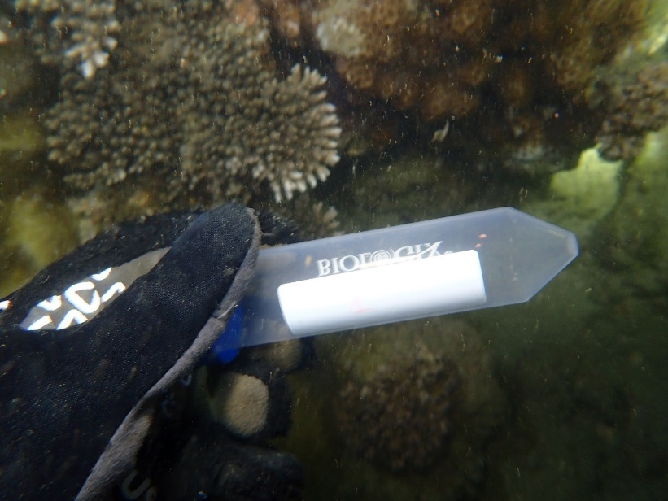
Figure 1. Coral gamete sampling
4. Units of measurement
All units of measurement (in the international system of units - SI) should follow the numerical value, separated by a single space, except in specific cases where the unit is placed directly after the number, such as for: angular units degrees (°), minutes (′), and seconds (″)), temperature (°C), and the percent symbol (%). For example: 15 m; 120 mg/L; 12 kg; 120 people/km²; 90°; 40%; 30°C (noting that the temperature unit should be formatted as °C rather than 0C).
Additional guidelines include:
For units of volume (liter, milliliter, etc.), use uppercase letters to prevent confusion with the number “1”. For example, use 2 mg/L; 5.0 mL (not 2 mg/l or 5.0 ml).
For other unit abbreviations, such as kWh, use lowercase as in “kWh” (not KWh).
Ensure consistency with SI conventions by writing “GPa” or “Pa” instead of “Gpa” or “pa.
5. Guidelines for referencing format
* Author name formatting in references
- Write the author’s name exactly as it appears on the reference.
- For two authors: List both of the authors, separated by commas.
- For three to six authors: List all authors, separated by commas, adding "and" before the last author.
- For seven or more authors: only list the first author’s name followed by “et al”.
* Order of references
- References should be arranged in ascending order according to the order they appear in the text.
- The format should be set to display reference numbers in a "hanging" style, where all lines after the first are indented to align with the first line.
* Non - english references
- For references in English, the titles should remain unchanged, without transliteration or translation.
- For references in other languages, the title should be translated into English, with the original title placed in parentheses right after the translated title. The author's name should be transliterated into the Latin alphabet.
* Presentation of references of different types: Pay attention to periods, commas, spacing, italics, and parentheses when formatting references of different types.
- Referencing books:
Format: No. Author’s name, Title of book, edition (if not first). Place of publication, Publisher, year, number of page.
Example:
- B. Rieder, Engines of order: A Mechanology of algorithmic techniques. Amsterdam, Univ. Press., 2020, 202 p.
- J. L. Spudich, B. H. Satir, Eds., Sensory receptors and signal transduction. New York, Wiley-Liss, 2001, 305 p.
- Council of Biology Editors, Scientific style and format: The CBE manual for authors, editors, and publishers, 6th ed..Chicago, Cambridge University Press, 2006, 412 p.
- Referencing a chapter in a book:
Format: No. Author(s) of chapter, Title of chapter - italicized in Title of book, Vol., edition (if not first), name of editor(s), editor (s). Place of publication, Publisher, year, pp. page gange.
Example:
4. G. O. Young, Synthetic structure of industrial plastics in Plastics, 2nd ed., Vol. 3, J. Peters, Ed.. New York, McGraw-Hill, 1964, pp. 15-64.
- Referencing articles in newspapers or academic journals:
Note: Digital Object Identifier (DOI) should be given at the end of your reference if it has a DOI
Format: No. Author(s) of paper, Title of paper - italicized, Journal name, volume number, issue number, pp. page gange, year. DOI: xx.xxxxxxxxxx (if available)
Example:
- G. Liu, K. Y. Lee and H. F. Jordan, TDM and TWDM de Bruijn networks and shufflenets for optical communications, IEEE Trans. Comp., Vol. 46, pp. 695-701, 1997.
- K. A. Nelson, R. J. Davis, D. R. Lutz, and W. Smith, Optical generation of tunable ultrasonic waves, Journal of Applied Physics, Vol. 53, No. 2, pp. 1144-1149, 2002.
- J. Attapangittya, Social studies in gibberish, Quarterly review of doublespeak, Vol. 20, No. 1, pp. 9-10, 2003.
- Referencing papers in Conference Proceedings:
Format: No. Author(s) of paper, Title of paper - italicized in Title of conference’s proceeding, place of organization, time of organization. Place of Publication, Publisher, year of publication, pp. page gange.
Example:
8. L. Liu, H. Miao, A specification based approach to testing polymorphic attributes in Formal methods and software engineering: Proceedings of the 6th international conference on formal engineering methods, ICFEM 2004, Seattle, WA, USA, November 8-12, 2004, J. Davies, W. Schulte, M. Barnett, Eds. Berlin, Springer, 2004, pp. 306-19. (Conference paper)
9. T. J. van Weert, R. K. Munro, Eds., Informatics and the digital society: Social, ethical and cognitive issues: IFIP TC3/WG3.1&3.2 Open Conference on Social, Ethical and Cognitive Issues of Informatics and ICT, Dortmund, Germany, July 22-26, 2002. Boston, Kluwer Academic, 2003. (Conference proceedings)
- Referencing Theses and Dissertations:
Format: No. Author, Title of thesis - italicised, Doctoral dissertation/Master's thesis. Institution, Location, year of preparation of thesis.
Example:
10. J. O. Williams, Narrow-band analyzer, Ph.D. dissertation. Dept. Elect. Eng., Harvard Univ., Cambridge, MA, 1993.
- Referencing Online Documents:
Format: No. Author(s) of document, Title of document - italicised, Time document created or revised. [Online]. Availabe: http://www... [Accessed mm dd yyyy].
Example:
11. H. Ayasso, A. Mohammad-Djafari, Joint NDT image restoration and segmentation using Gauss-Markov-Potts prior models and variational bayesian computation, IEEE Transactions on image processing, Vol. 19, No. 9, pp. 2265-77, 2010. [Online]. Available: IEEE Xplore, http://www.ieee.org. [Accessed Sept. 10, 2010].
12. A. Altun, Understanding hypertext in the context of reading on the web: Language learners’ experience, Current issues in education, Vol. 6, No. 12, July, 2005. [Online serial]. Available: http://cie.ed.asu.edu/volume6/number12/. [Accessed Dec 2, 2007].

